Let’s Build Something Circuit Board Matrix:

Start with two pieces of 4” X 6” Single Sided Copper Board, using the 0.069 thick board material. Use a Miter Box for cutting the PC Board, Cut with 32 tooth Hacksaw blade. Wear a mask while cutting the board –the residual dust is a health hazard! Three saw cuts are all that is required.

Board | Size
Audio Amplifier Board | 2” X 4” Cut from the 2nd PC Board
Double Balanced Mixer | 2” X 3” Cut from the 1st PC Board
Band Pass Filter | 2” X 3” Cut From the 1st PC Board
Rx & Tx RF Amplifier Board | 3” X 4” Cut From the 1st PC Board
DDS/Arduino Base Board | 4” X 4” Cut from the 2nd PC Board

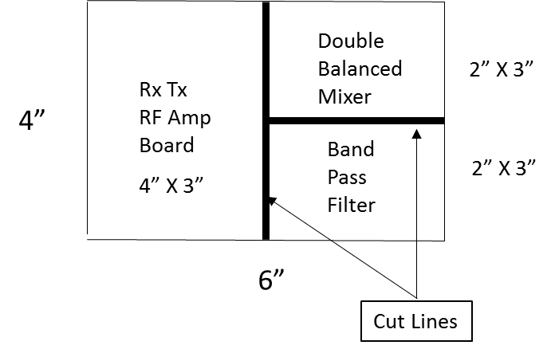

Layout and Cut Pattern for PC Board # 1

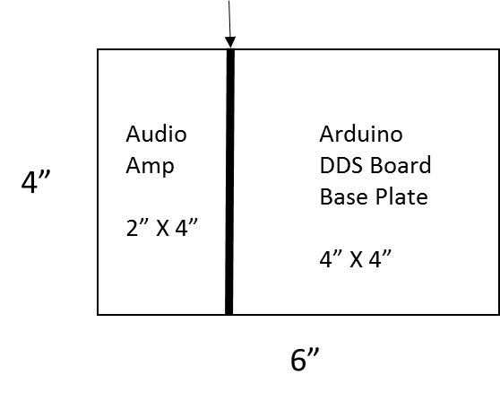
PC Board # 2 Layout and Cut Pattern

